PawsWatch Community Cat Center
Sponsored by Grieco
Automotive Group
Volunteer Application

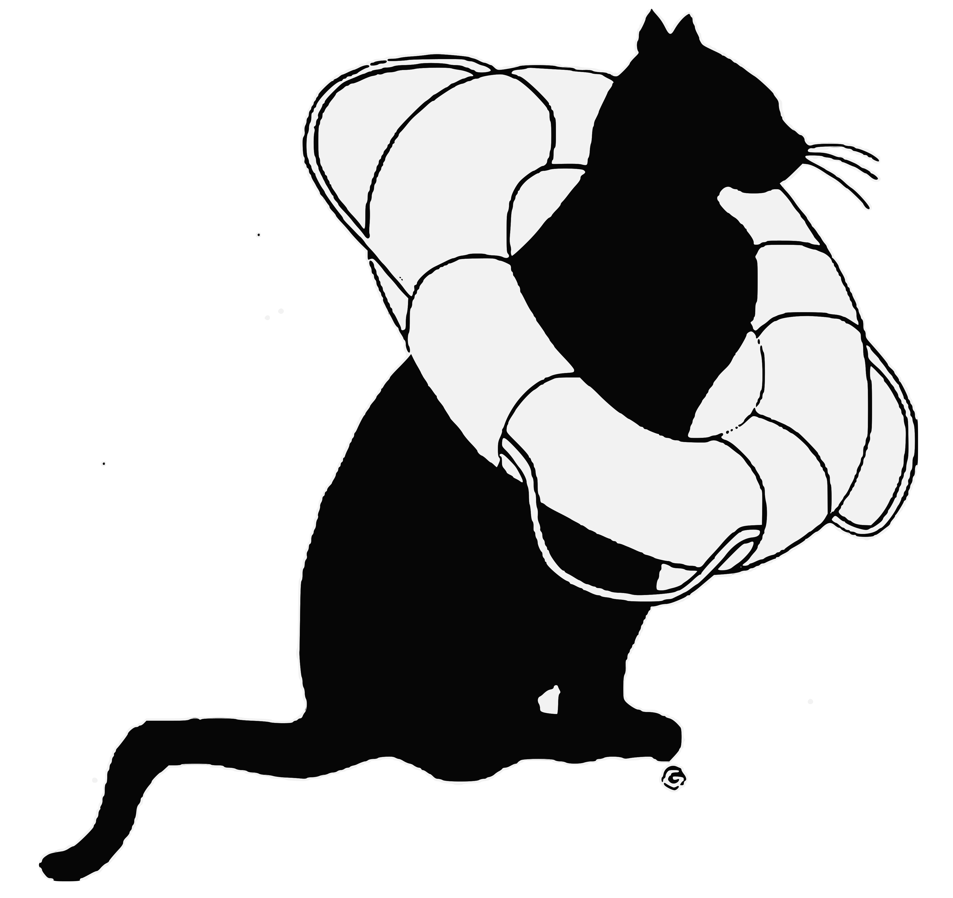

Complete this form and email it to Karen Luther at zorissa4@cox.net and someone will call you with information on how to volunteer.

Full Name ________________________________________________________________________
Street : ____________________________City: ___________________State: ______ Zip: ________ Phone Numbers: (Cell): ________________________ (Home/Work): ________________________ Email Address: ____________________________________________________________________
Today’s Date: _________________________________________________

How to volunteer:
In the Center-The Community Cat Center houses a number of feral and abandoned cats in our pre and post-op center. Volunteering at the center is a time commitment and entails feeding, cleaning and socializing our furry guests

TNR (Trap – Neuter – Return)-Volunteers assist in the the humane trapping of feral and abandoned cats to provide spay/neuter, vaccinating and returning healthy cats back to their environment. Also, encouraging and teaching neighbors how to get involved in the TNR process
Transport- An integral part of and our operation as an animal rescue. Transport involves bringing cats/kittens to the vet to ensure our animals are in peak health condition.
Foster- Sometimes a cat needs some special one-on-one care that can’t be provided at a very busy animal shelter. A foster offers their home, time, & love to provide care for those special cats or kittens who have the greatest needs.

Please check the programs that interest you:
Cat care at the Center Creative Writing Skills
Fostering Feeding Colonies
Trapping Assist at Adoption Events
Transportation to and from Veterinarian Social Media Management
Grant Writing Soliciting Businesses for Donations
Communications/Promotions Fundraising Committee
Do you have special skills to offer us?

Carpentry Website Management Veterinary/Kennel Experience Plumbing Electrical
Accounting
Please tell us why you’d like to volunteer at our Community Cat Center: ________________________________________________________________________________ ________________________________________________________________________________
How many hours per week are you interested in volunteering for Community Cat Center? A minimum of four hours per month is required of our volunteers.
______________ Hours per Week or ________________ Hours per Month

Please tell us which days and time periods you are available. Circle all that apply.
Monday | 9 AM to 12 PM | 11 AM to 2 PM | 6 PM to 9 PM
Tuesday | 9 AM to 12 PM | 11 AM to 2 PM | 6 PM to 9 PM
Wednesday | 9 AM to 12 PM | 11 AM to 2 PM | 6 PM to 9 PM
Thursday | 9 AM to 12 PM | 11 AM to 2 PM | 6 PM to 9 PM
Friday | 9 AM to 12 PM | 11 AM to 2 PM | 6 PM to 9 PM
Saturday | 9 AM to 12 PM | 11 AM to 2 PM | 6 PM to 9 PM
Sunday | 9 AM to 12 PM | 11 AM to 2 PM | 6 PM to 9 PM

Thank you for your interest in helping the community cats of Rhode Island!

Signature: _______________________________________________________________________

PawsWatch
POBox 7005
Warwick, RI 02887
39 Putnam Pike
Johnston, RI 02919
(401) 603-0368
www.pawswatch.org
facebook.com/catcenterRI @catcarecenterri on Instagram

